SUBJECT:  APPLICATIONS DEVELOPMENT THEORY  (APT470S)  Full time and part time | EXAM DATE:  JUNE 2023 | DURATION:  120 Minutes | TOTAL MARKS:  75



DEPARTMENT OF INFORMATION TECHNOLOGY
FACULTY OF INFORMATICS AND DESIGN

COURSE(S): ADICTA: ADVANCED DIPLOMA IN INFORMATION AND COMMUNICATION TECHNOLOGY: APPLICATIONS DEVELOPMENT

EXAMINER: MS G KHAN
MODERATOR: MR T MAKHURANE
EXTERNAL MODERATOR: DR M NORMAN

GENERAL INSTRUCTIONS
- You are required to answer all questions.
- All test questions relate to the scenario supplied below. Read it carefully before answering the questions.
- This test counts 30% of your final mark for this subject and covers work from terms 1 and 2 as per the topic list in the Subject Guide.

Scenario for the MommyCare Patient Information System

MommyCare is a patient information system that keeps track of the maternal health and care provided to pregnant women. Most of these patients do not require dedicated hospital treatment and can instead attend specialist clinics to meet a healthcare practitioner. To make it easier for the patients to attend, the clinics are run in several locations across the city including hospitals, local medical centres, community centres and occasionally there is home-based care. The MommyCare system was initially developed as a desktop system which makes use of a centralized database before it was changed to a webApp so that it can be accessed remotely. When used from sites that do not have secure network connectivity a local copy of the patient records are used instead. The system is not a complete medical records system and so does not maintain information about other medical conditions. It may, however, interact and exchange data with other clinical information systems e.g. those for scans, blood work, medications etc.

This system has two purposes:
1. To generate management information that allows health service managers to assess performance against local and government targets.
2. To provide medical staff with timely information to support the treatment of maternal healthcare.
As maternal health is complex and prone to change patients may sometimes suddenly miss appointments or be hospitalized as the situation demands.

Users of the system include clinical staff such as doctors, nurses, midwives and home-based carers
(i.e. nurses who visit the patients at home to check on their health or administer treatments). Non-medical users include receptionists who make appointments, medical records staff who maintain the records system, and administrative staff who generate reports.
The system is used to record information about the patient (name, address, age, next of kin, etc.), consultations (date, doctor seen, subjective impressions of the patient, etc.), conditions, and treatments. Reports are generated at regular intervals for medical staff and health authority managers. Typically, reports for medical staff focus on information about individual patients, whereas management reports are on summarized and anonymized data that are concerned with conditions, costs of treatment, etc.

The key features of the system are:
1. Individual care management. Clinicians can create records for patients, edit the information in the system, view patient history, and so on. The system supports medical histories so that doctors who have not previously met a patient can quickly learn about the key problems and treatments that have been prescribed.
2. Patient monitoring. The system regularly monitors the records of patients that are involved in treatment and issues warnings if possible problems are detected. Therefore, if a patient has not seen a doctor for some time, a warning may be issued or if a notification is raised for patients that may have been transferred to a facility that offers a higher level of maternal healthcare. The monitoring of the development of the pregnancy is one of the most important elements of this system.
3. Administrative reporting. The system generates monthly management reports showing the number of patients treated at each clinic, the number of patients who have entered and left the care system, the number of patients transferred, the drugs prescribed and their costs, etc.

This system is affected by the laws on data protection that govern the confidentiality of personal information and is subject to strict legislative safeguards. One aim of the MommyCare system is to ensure that staff always act in accordance with the law and that their decisions are recorded for judicial review if necessary. As in all medical systems, privacy is a critical system requirement. It is essential that patient information is confidential and is never disclosed to anyone apart from authorized medical staff and the patient themselves.
The MommyCare system is also a safety-critical system. Wherever possible, the system should warn medical staff about potentially dangerous conditions that a patient may have or treatments that may carry higher risks.
The overall design of the system has to take into account privacy and safety requirements. The system must be available when needed; otherwise safety may be compromised, and it may be impossible to prescribe the correct medication to patients. There is a potential conflict here. Privacy is easiest to maintain when there is only a single copy of the system data. However, to ensure availability in the event of server failure or when disconnected from a network, multiple copies of the data should be
maintained.

QUESTION 1 (25 MARKS)

1.1 | New features are being considered for the MommyCare system and an Agile approach has been selected for its development. Identify the two most important attributes that make an Agile team unique and explain why these are critical to the team’s success. | 10
1.2 | As part of the effort to modernize the system you decide that it should be hosted on the Cloud. Prepare a list of reasons which explains why this could be a good option. | 5
1.3 | Determining the correct requirements is neither easy nor straightforward and sometimes software engineers add to the difficulty by making mistakes while eliciting requirements. Discuss the common errors that software engineers make during requirements gathering which can affect its correctness. | 5
1.4 | A mobileApp is needed for the MommyCare system and it has been decided to reuse as much of the existing interfaces of the desktop and webApp versions as possible. Explain why a domain analysis would be useful to the design of the mobileApp and mention two sources that could inform the creation of classes, and analysis and design patterns. | 5

QUESTION 2 (25 MARKS)

2 | You are working on a new feature named the Home-based Care subsystem that must be developed for use by a healthcare professional during a home visit. Carefully read the user story below before answering the questions that follow.  Georgia is a nurse who specializes in home-based healthcare. One of her responsibilities is to visit patients at home to check that their treatment is effective and that they are not suffering from medication side effects.  On a day for home visits, Georgia logs into the Home-based Care subsystem and uses it to print her schedule of home visits for that day, along with summary information about the patients to be visited. She requests that the records for these patients be downloaded to her laptop. She is prompted for her key phrase to encrypt the records on the laptop.  One of the patients whom she visits is Jean, who is being treated with medication for high blood pressure. Jean feels that the medication is helping her but believes that it has the side effect of keeping her awake at night. Georgia looks up Jean’s record and is prompted for her key phrase to decrypt the record. She checks the medicine prescribed and queries its side effects. Sleeplessness is a known side effect, so she notes the problem in Jean’s record and suggests that she visit the clinic to have her medication changed. Jean agrees so Georgia enters a prompt to call her when she gets back to the clinic to make an appointment with a physician. Georgia ends the consultation, and the system re-encrypts Jean’s record.  After finishing her consultations, Georgia returns to the clinic and uploads the records of patients she has visited to the database. The system generates a call list for Georgia of those patients whom she has to contact for follow-up information and make clinic appointments.
2.1 | The diagram below reflects the original Use Case model for the MommyCare system. Provide the following missing information needed for the model to reflect the new Home-based Care subsystem.  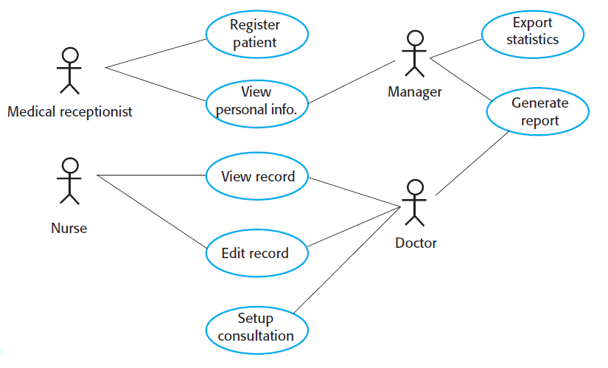
2.1.1 | One additional actor for the Home-based Care subsystem. | 1
2.1.2 | Two additional use cases plus an associated includes case for each | 4
2.2 | What are the two fundamental issues that need consideration when a systems architecture is being designed to maintain security? Explain how these issues could be addressed for the Home-based Care subsystem. | 5
2.3 | The work products produced during requirements engineering must be assessed for quality during requirements validation. Explain why this validation is needed. | 6
2.4 | Discuss three techniques that would be used to validate requirements. | 9

QUESTION 3 (25 MARKS)

3.1 | The use of social media in software engineering has grown and shown benefits in creating a sense of “connection” within the development team. This is particularly true for larger teams or those that are geographically dispersed. Explain social media such as Blogs, Microblogs, Targeted online forums and Social networking sites can be used in software engineering to improve work whenever an issue, a question, or a problem arises. | 10
3.2 | Examine the statement below before explaining how this applies to the design of the usability and accessibility of the mobileApp for the Home-based Care subsystem. Use examples to support your answer.  “The overriding design goals for mobileApps are that of ubiquity, personalization, flexibility, and localization.” | 15

****** END OF PAPER *******

